- Create a Simple Pod Using YAML Task: Write a YAML file to create a Pod named firstpod with an nginx container. Verify the Pod creation using kubectl get pods and check the logs of the container using kubectl logs firstpod.
1. Login to Master
ssh ... k8s-master
2. Create YAML
vi firstpod.yaml
Add:
apiVersion: v1
kind: Pod
metadata:
name: firstpod
spec:
containers:
- name: nginx
image: nginx 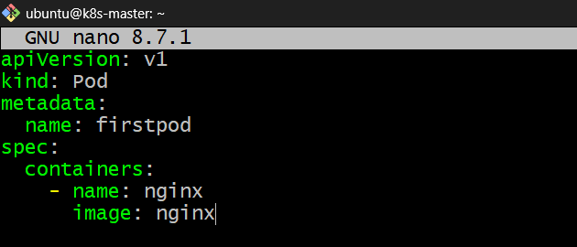
3. Create Pod
kubectl apply -f firstpod.yaml 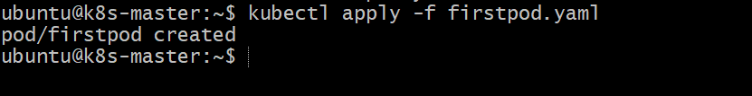

4. Check Pod
kubectl get pods 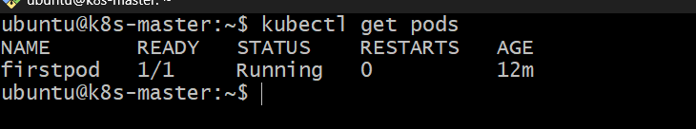
5. Check where Pod is running
kubectl get pods -o wide
You may see:
NAME READY STATUS NODE
firstpod 1/1 Running k8s-worker1
It could also be k8s-worker2.
6. Check logs
kubectl logs firstpod 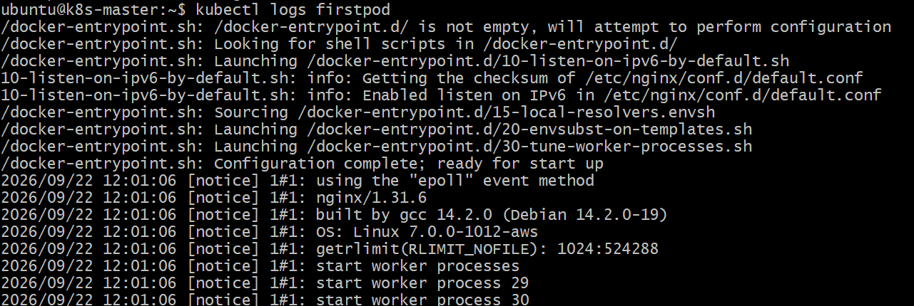

- Set Environment Variables in a Pod Task: Modify the YAML file to include environment variables myname: sabair and City: Hyderabad. Deploy the Pod and use kubectl exec <pod_name> -- env to check if the environment variables are set properly.
1. Connect to k8s-master
In VS Code terminal:
ssh ubuntu@<MASTER-IP>
Or use Remote-SSH and connect to k8s-master.

2. Go to your working directory
cd ~
3. Create a new YAML file
vi envpod.yaml
Add:
apiVersion: v1
kind: Pod
metadata:
name: envpod
spec:
containers:
- name: nginx
image: nginx
env:
- name: myname
value: "sabair"
- name: City
value: "Hyderabad"
Save:
Esc
:wq
Enter 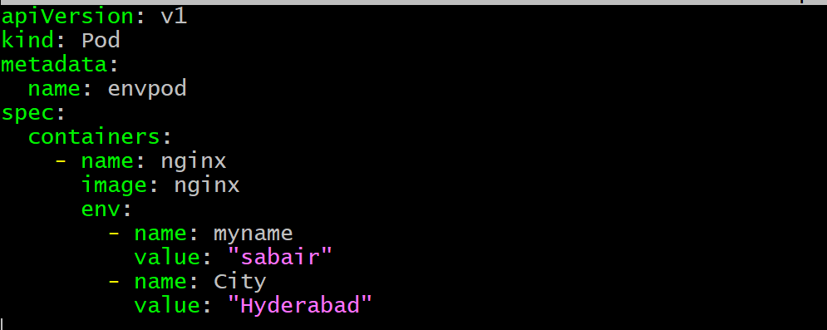

4. Create the Pod
kubectl apply -f envpod.yaml 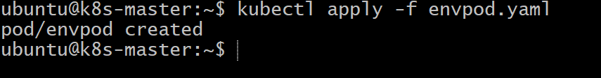
Expected:
pod/envpod created

5. Check the Pod
kubectl get pods 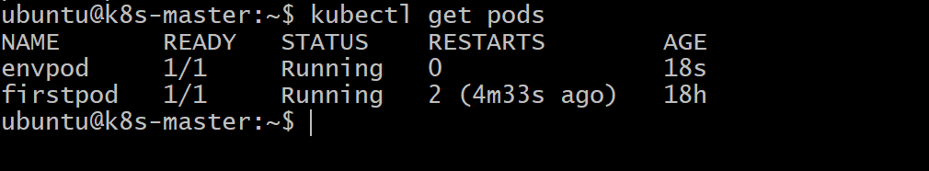

6. Check Environment Variables
kubectl exec envpod -- env
Look for: 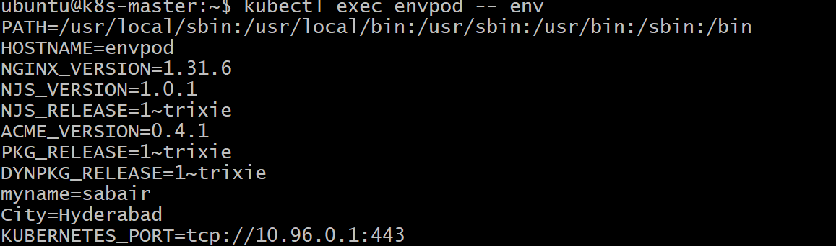
This way, each Kubernetes task has its own YAML file, which is easier to learn and troubleshoot.

- Deploy a Pod with Commands (Args) in YAML Task: Modify the YAML file to add args that instruct the container to sleep for 50 seconds. Deploy the Pod and use kubectl describe pod to verify the args are correctly passed to the container.
Since this is a new task, create a new YAML file on k8s-master.
1. Create YAML file
nano argspod.yaml
Add:
apiVersion: v1
kind: Pod
metadata:
name: argspod
spec:
containers:
- name: nginx
image: nginx
args:
- "sleep"
- "50"
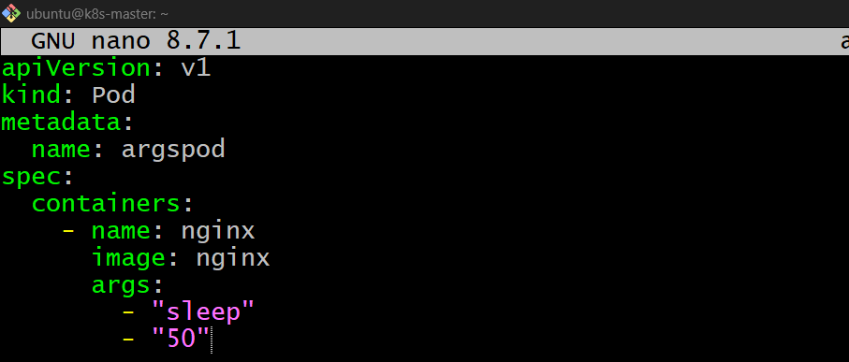
Note: The nginx image does not normally use sleep as its entrypoint, so for this task use a simple image such as busybox:
2. Create the Pod
kubectl apply -f argspod.yaml
3. Check Pod
kubectl get pods 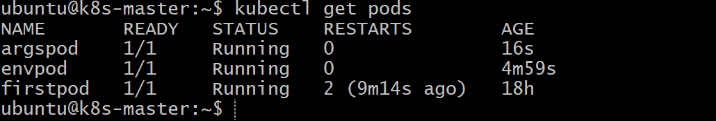
It will run for approximately 50 seconds and then finish.
4. Verify the args
kubectl describe pod argspod 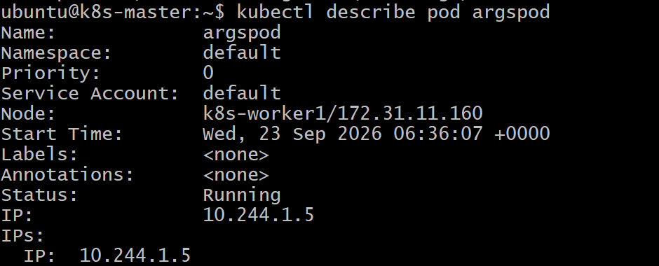
Look for:
Args:
sleep
50 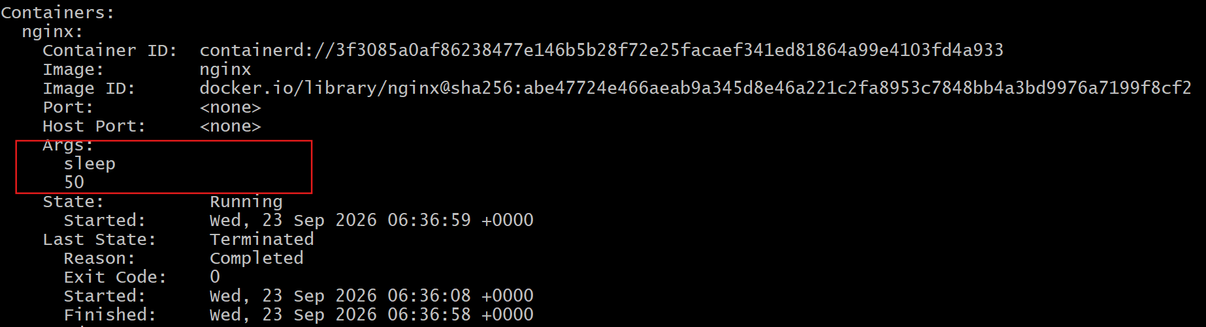
5. Check status
kubectl get pod argspod 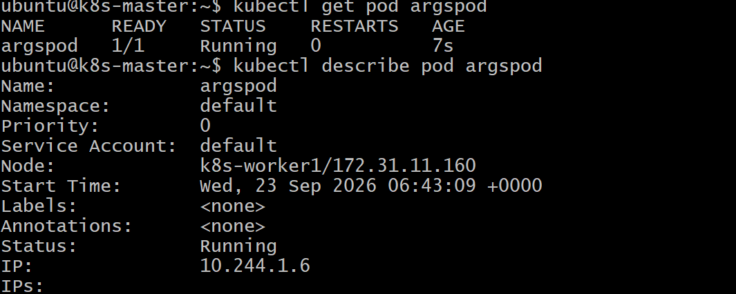
After 50 seconds, you may see:
Completed

- Create a Pod with Two Containers Task: Create a YAML file to define a Pod with two nginx containers inside. Use kubectl exec to access both containers and verify that both containers can communicate through the same network (e.g., using telnet between them).
1. Create YAML
nano twocontainers.yaml
Add:
apiVersion: v1
kind: Pod
metadata:
name: twocontainers
spec:
containers:
- name: nginx1
image: nginx

- name: nginx2
image: nginx
Save:
Esc
:wq
Enter 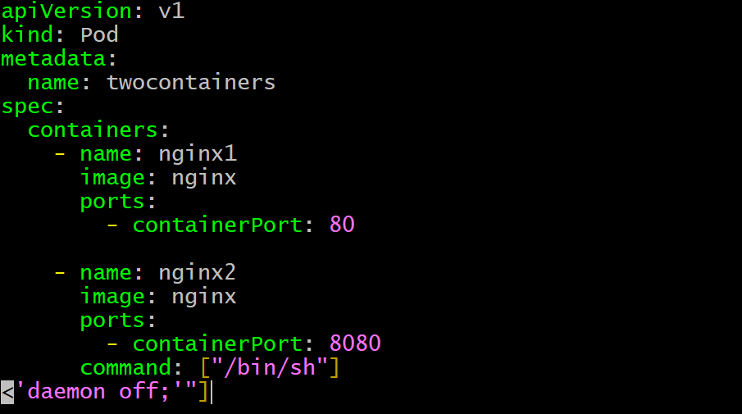
2. Create the Pod
kubectl apply -f twocontainers.yaml
3. Verify
kubectl get pod twocontainers
Expected:
NAME READY STATUS
twocontainers 2/2 Running
2/2 means both nginx containers are running.
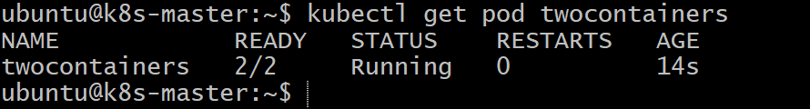
4. Check both containers
kubectl exec twocontainers -c nginx1 -- nginx -v
kubectl exec twocontainers -c nginx2 -- nginx -v 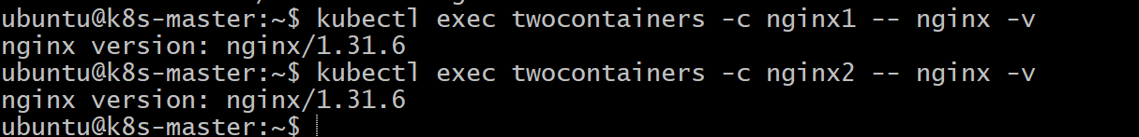
5. Verify they share the same network
Get the Pod IP:
kubectl get pod twocontainers -o wide
Both containers use the same Pod IP because containers inside one Pod share the same network namespace.
You can verify from nginx1:
kubectl exec twocontainers -c nginx1 -- hostname -i
And:
kubectl exec twocontainers -c nginx2 -- hostname -i
Both should show the same Pod IP. 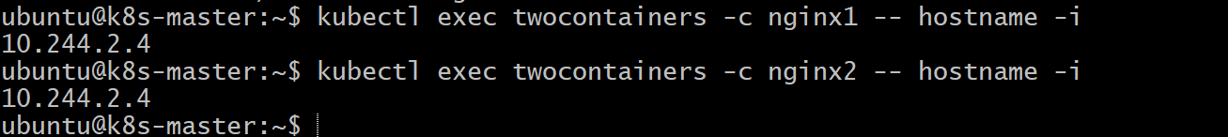
- Containers in the same Pod share one IP.
- They use different ports to avoid conflict.
- They can communicate using localhost.

- Set Up an Init Container in a Pod Task: Modify the YAML to include an init container that sleeps for 30 seconds before the main containers start. Verify the init container's execution using kubectl describe pod and check the logs to confirm its completion.
Purpose: Init container runs first and completes its task before the main container starts.
Step 1 — Create YAML
nano initpod.yaml
apiVersion: v1
kind: Pod
metadata:
name: initpod
spec:
initContainers:
- name: init-container
image: busybox
command: ["sleep", "30"]

containers:
- name: nginx
image: nginx 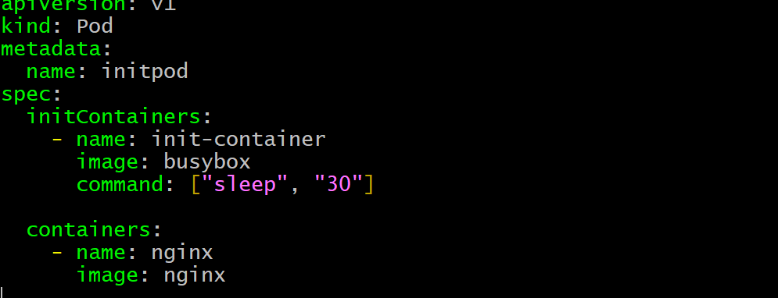
Step 2 — Create Pod
kubectl apply -f initpod.yaml 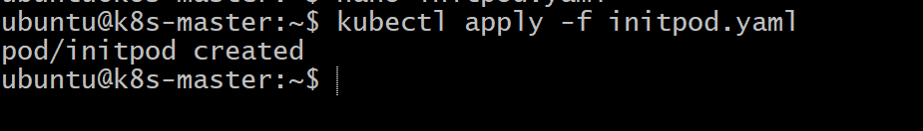
Step 3 — Verify
kubectl get pod initpod
During the first 30 seconds:
0/1 Init:0/1
After 30 seconds:
1/1 Running 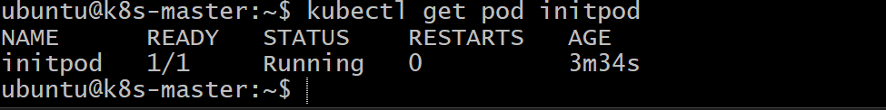
Step 4 — Check Init Container
kubectl describe pod initpod 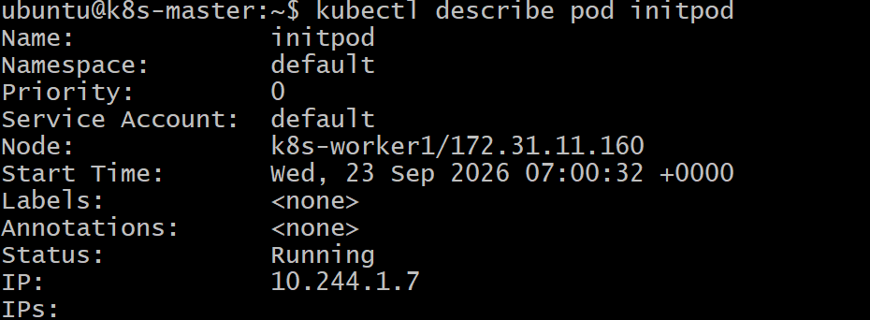
Step 5 — Check Logs
kubectl logs initpod -c init-container
Key point: Main container starts only after the init container successfully completes.

- Run a Dry Run Command to Generate YAML Task: Use the kubectl run nginx --image=nginx --dry-run=client -o yaml command to generate a Pod YAML definition. Modify the generated YAML to suit specific requirements (e.g., labels or environment variables) and deploy it.
Purpose: Generate a Pod YAML file without creating the Pod, then modify and deploy it.
Step 1 — Generate YAML
kubectl run nginx --image=nginx --dry-run=client -o yaml > nginx-dryrun.yaml

Step 2 — Edit YAML
nano nginx-dryrun.yaml
Add/modify requirements, for example:
metadata:
name: nginx
labels:
app: web 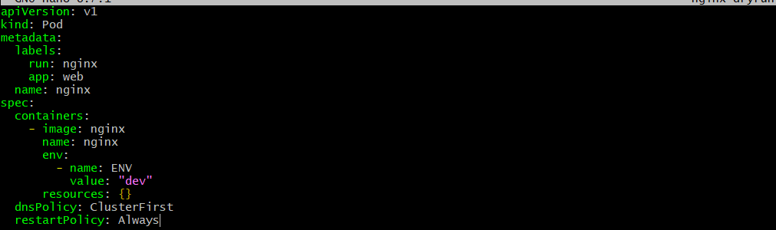
Step 3 — Deploy Pod
kubectl apply -f nginx-dryrun.yaml
Step 4 — Verify
kubectl get pods 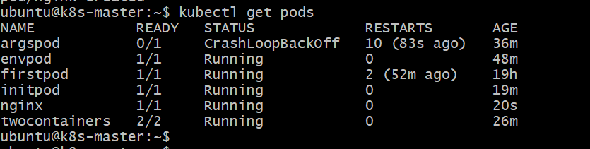
kubectl get pod nginx --show-labels 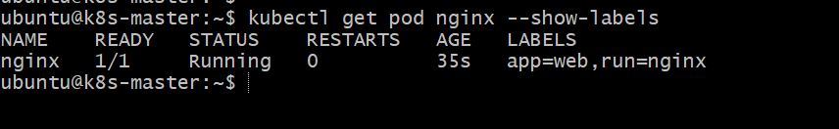
Key point: --dry-run=client generates the YAML without creating the resource.

- Use kubectl apply vs kubectl create Task: Create a YAML file to define a Pod. First, deploy it using kubectl create -f <file_name>.yml and then modify the YAML (e.g., change the image version). Use kubectl apply to redeploy and verify the difference between both commands.
Purpose: Understand the difference between create and apply when creating and updating Kubernetes resources.
Step 1 — Create YAML
nano createpod.yaml
apiVersion: v1
kind: Pod
metadata:
name: createpod
spec:
containers:
- name: nginx
image: nginx:1.25 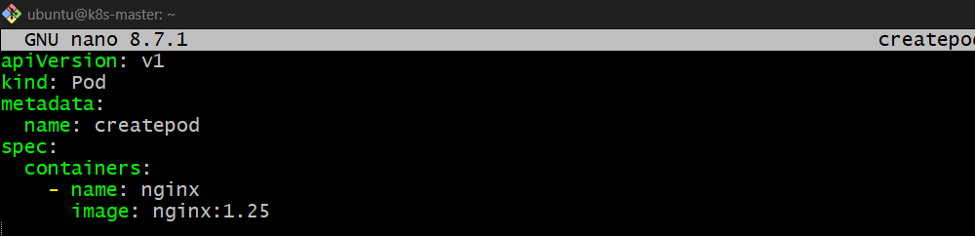
Step 2 — Create the Pod using kubectl create
kubectl create -f createpod.yaml 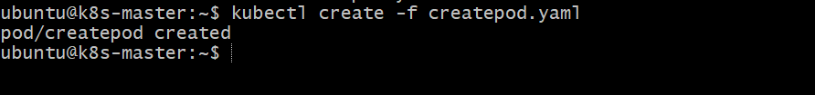

Verify:
kubectl get pod createpod 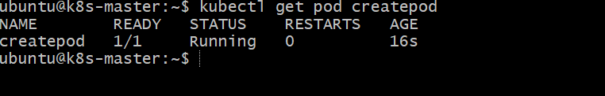
Step 3 — Modify the YAML
Change:
image: nginx:1.25
to:
image: nginx:1.27 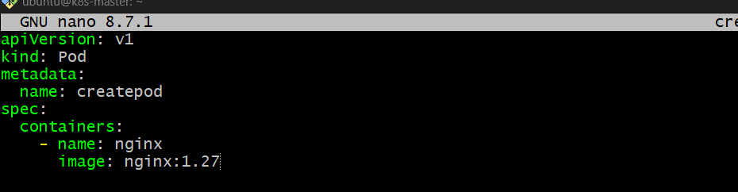
Step 4 — Use kubectl apply
kubectl apply -f createpod.yaml 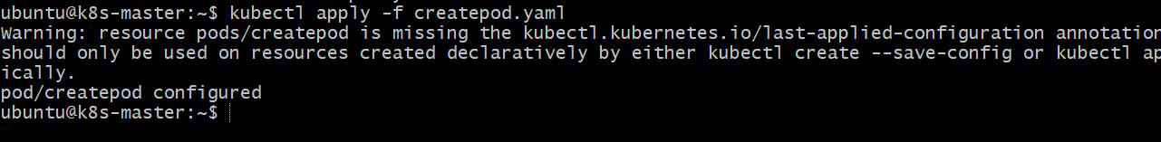
Check:
kubectl get pod createpod 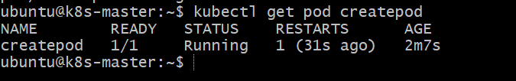
Important difference
Command | Purpose
kubectl create | Creates a resource only if it doesn't exist
kubectl apply | Creates or updates a resource
What happens here?
kubectl create
↓
Pod created with nginx:1.25
↓
Modify YAML → nginx:1.27
↓
kubectl apply
↓
Kubernetes attempts to update the Pod

- Edit an Existing Pod Configuration Task: Use kubectl edit pod <pod_name> to modify the running Pod's environment variables or image. After making the changes, verify if they took effect by checking the container logs or environment variables using kubectl exec.
Purpose: Learn how to directly modify an existing Pod using kubectl edit and understand which Pod settings can or cannot be changed.
Step 1 — Create a Pod
nano editpod.yaml
apiVersion: v1
kind: Pod
metadata:
name: editpod
spec:
containers:
- name: nginx
image: nginx
env:
- name: ENV
value: "dev" 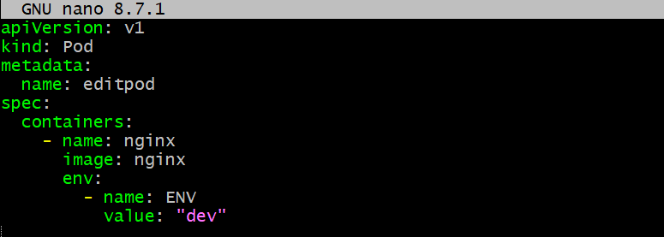
Create it:
kubectl apply -f editpod.yaml 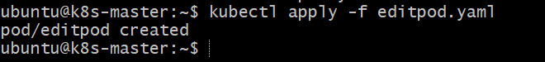
Step 2 — Edit the Running Pod
kubectl edit pod editpod
Find:
value: "dev"
Change to:
value: "production"
Save and exit. 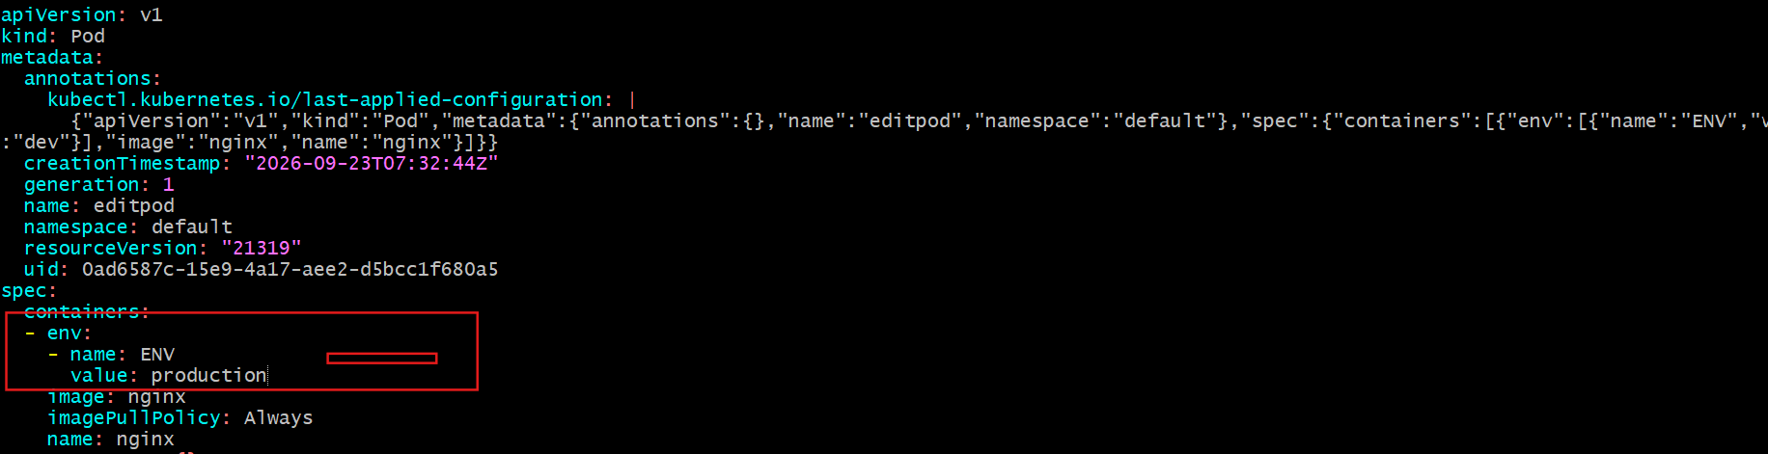
Step 3 — Verify
kubectl exec editpod -- env | grep ENV
Expected:
ENV=production
⚠️ Important
Not every Pod field can be changed using kubectl edit.
For example, changing:
image: nginx
may be allowed, but many Pod spec fields are immutable. If Kubernetes rejects the change, recreate the Pod instead:

- Expose a Pod Using a Service Task: Create a YAML file to expose your firstpod using a Service (ClusterIP). Ensure that your service is exposing the Pod on port 80 and verify it using kubectl get svc.
Purpose: A Kubernetes Service provides a stable network endpoint to access a Pod. Pod IPs can change when Pods are recreated, so we use a Service instead of connecting directly to the Pod IP.
Step 1 — Check firstpod
kubectl get pod firstpod --show-labels
If your firstpod has no label, add one to the Pod YAML and recreate it. 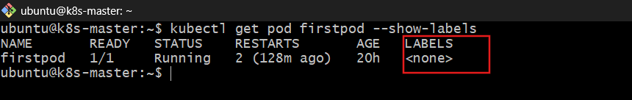
Example label:
metadata:
name: firstpod
labels:
app: nginx 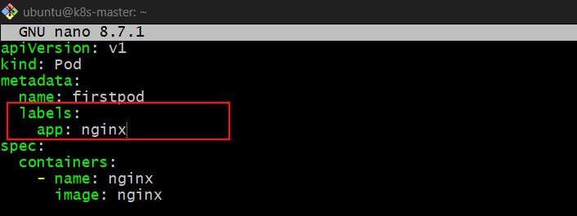
Then:
kubectl delete pod firstpod
kubectl apply -f firstpod.yaml 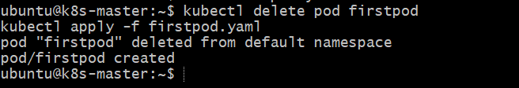
Step 2 — Create Service YAML
nano firstpod-service.yaml
apiVersion: v1
kind: Service
metadata:
name: firstpod-service
spec:
type: ClusterIP
selector:
app: nginx
ports:
- port: 80
targetPort: 80 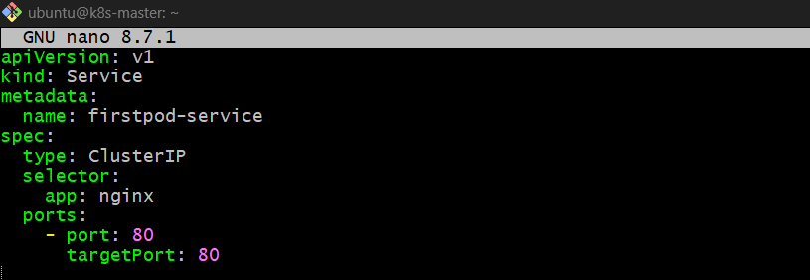
Step 3 — Create the Service
kubectl apply -f firstpod-service.yaml
Step 4 — Verify
kubectl get svc
You should see:
firstpod-service ClusterIP 10.x.x.x <none> 80/TCP 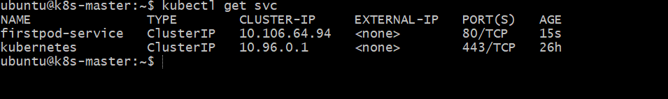
Check the endpoints:
kubectl get endpoints firstpod-service
You should see the Pod IP:80.
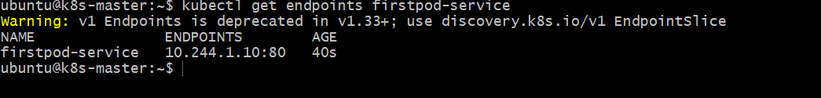
Why are we using selector?
selector:
app: nginx
The Service finds Pods having:
labels:
app: nginx
So the flow is:
Client
↓
Service :80
↓
Selector: app=nginx
↓
firstpod :80
If changes happen, why?
Pod IP can change: If the Pod is deleted/recreated, Kubernetes can assign a new IP.
Service IP stays stable: The ClusterIP remains the same while the Service exists.
Service automatically updates endpoints: Kubernetes detects the new Pod matching the selector and sends traffic to it.

- Pod with Resource Limits and Requests Task: Add resource requests and limits to the containers in your YAML file. Specify CPU and memory requests/limits for both containers and deploy the Pod. Use kubectl describe pod to verify if the resource configurations are correctly applied.
Purpose: Define how much CPU and memory a container needs and the maximum resources it is allowed to use.
- Requests → minimum resources reserved for the container.
- Limits → maximum resources the container can use.
Step 1 — Create YAML
nano resourcepod.yaml
apiVersion: v1
kind: Pod
metadata:
name: resourcepod
spec:
containers:
- name: nginx1
image: nginx
resources:
requests:
cpu: "100m"
memory: "128Mi"
limits:
cpu: "200m"
memory: "256Mi"

- name: nginx2
image: nginx
resources:
requests:
cpu: "100m"
memory: "128Mi"
limits:
cpu: "200m"
memory: "256Mi"
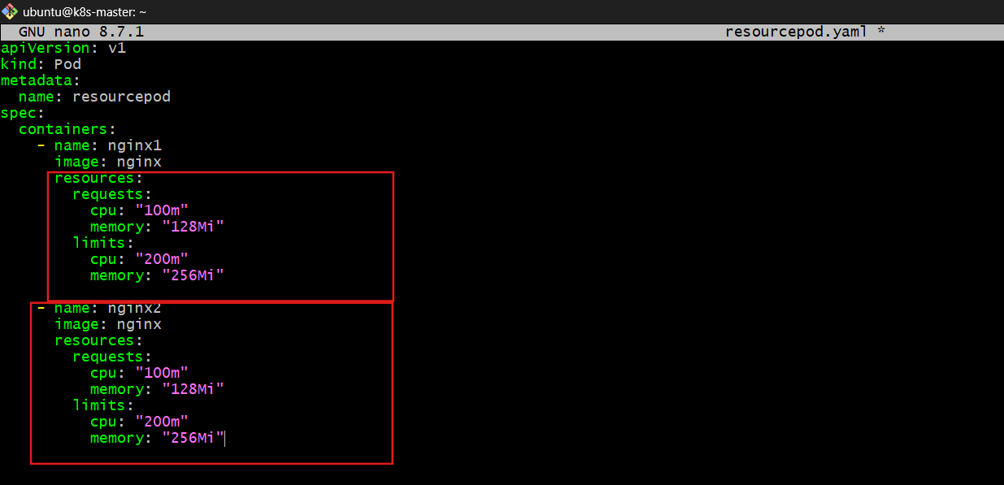
Step 2 — Deploy
kubectl apply -f resourcepod.yaml 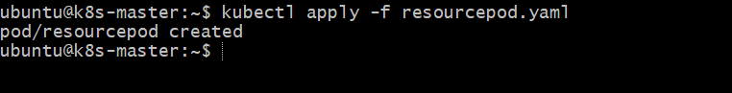
Step 3 — Check Pod
kubectl get pod resourcepod
Expected:
resourcepod 2/2 Running 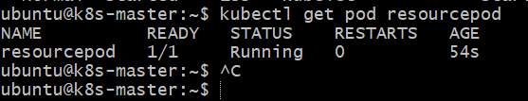
Step 4 — Verify Resources
kubectl describe pod resourcepod 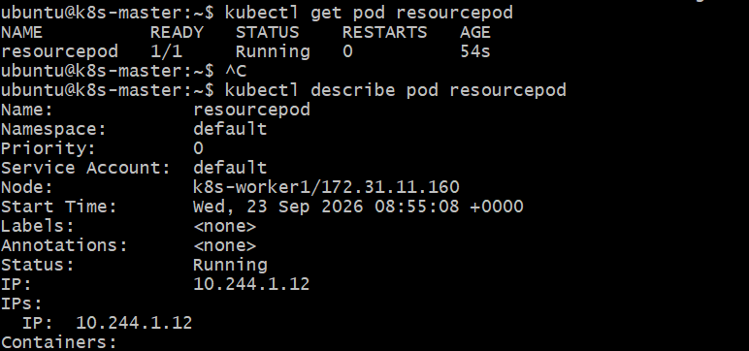
Look under each container:
Requests:
cpu: 100m
memory: 128Mi
Limits:
cpu: 200m
memory: 256Mi
Why do we use Requests and Limits?
Requests → Kubernetes uses this for scheduling
↓
"How much does this Pod need?"

Limits → Restricts maximum usage
↓
"How much can this container use?"

Example: If a container requests 100m CPU, Kubernetes looks for a node with at least that amount of available CPU capacity for scheduling. If it tries to use more than its 200m CPU limit, Kubernetes throttles CPU usage.

